**Introduction to SQLite**

09/25/2020 Created by Smita Dutta

May/7/2022 Reviewed by Wenzhi Xu

School of Technology & Computing (STC)

City University of Seattle (CityU)

Center for Information Assurance (CIAE) @City University of Seattle (CityU)



**Before You Start**

* The directory path shown in screenshots may be different from yours.
* Some steps might not be explained in the tutorial.  If you are not sure what to do:
  + Consult the resources listed below.
  + If you cannot solve the problem after a few tries, ask a TA for help.

**Learning Outcomes**

* How to work with SQLite Studio
* Download and setting up of SQLite Studio

**Resources**

* SQLite Studio Documentation: <https://sqlitestudio.pl/features/>

**Working with SQLite Studio**

**Download and Setup**

In order to follow along with the exercises there's a couple of things you'll need to do. You'll need a compatible database system. We will use SQLite in this. SQLite is a simple compact standards-compatible database management system that's easy to install and cross-platform compatible. The SQLite studio package includes the database along with a management environment. You can download it at [www.sqlitestudio.pl](http://www.sqlitestudio.pl)

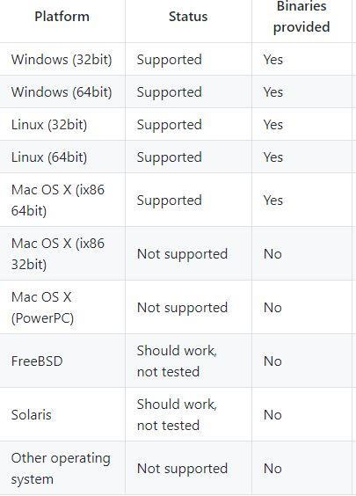

You'll also need a plain text editor. A plain text editor is different than a word processor. A word processor is designed for writing documents, and includes a lot of formatting information along with the text. That formatting information will actually interfere with the SQL code in the example files. So, a word processor will not work for this purpose.

I recommend you to install Visual Studio Code to support your work. Please follow this link <https://cityuseattle.github.io/docs/tools/vscode/> to install it.

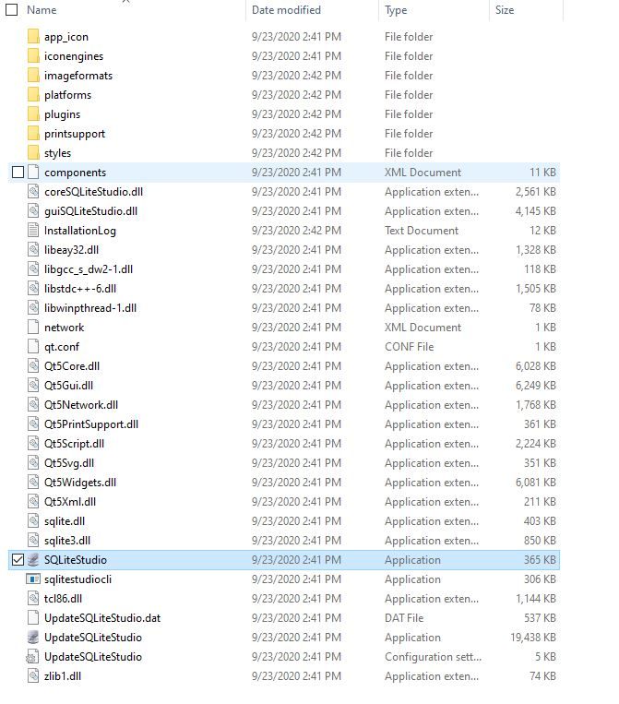After downloading SQLite Studio from the link, go ahead and double-click on the installer, and select Next, Welcome to the Setup Wizard, select Next, and accept all of the defaults. We're going to register these file extensions, and create a Start menu entry.

**For Windows users:**

If you see the following pictures, double click the high-lighted SQLite Studio and follow the two images.

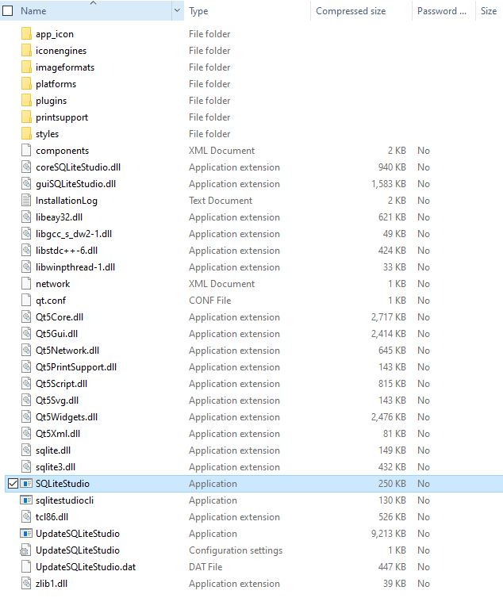

Double click on that and select the language.

It's basically installing the entire package and we may not need all of these bits but none of them take up much space and it doesn't really hurt us. So, we're just going to accept all of the defaults, and select Next. Now it says it's ready, and so we'll select Install. If you get the User Account Control dialog, select Yes.  Run it and select Finish. Choose a language, and there we have it.

**Creating new database**

You can create new database by following the instructions:

1. Click on toolbar button:
2. 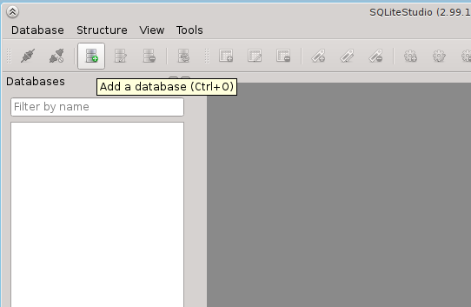Click on main menu entry:

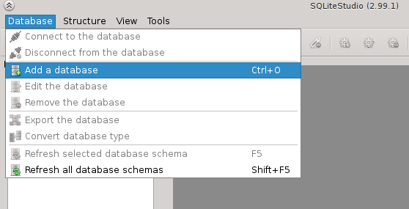

1. Right-click on database list and pick entry from context menu:
2. 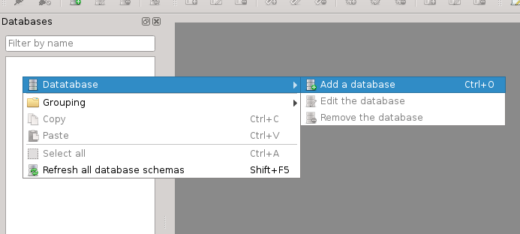

Then the database dialog will appear:

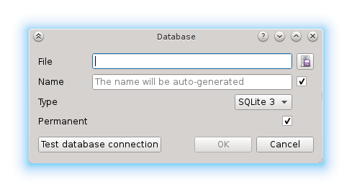

Click on the browse button:

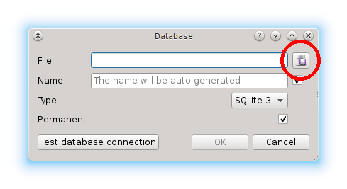

You will see filesystem browsing dialog (this may look different on various operating systems):

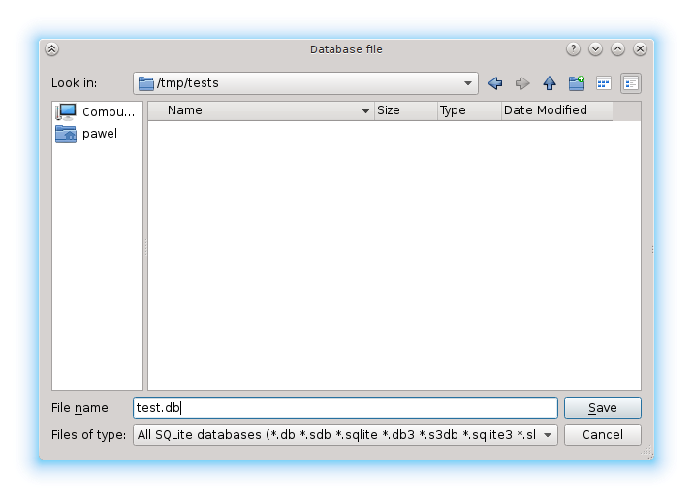In this dialog go to directory where you want to create your database and type in the file name for your database (on the image above it's "test.db"). Click "Save". Now the database dialog has file name and database name filled in. You can change the name to whatever you want (in which case you have to disable the checkbox on the right hand side), or just leave it as it is.

**The database name is just symbolic name, an alias used by SQLiteStudio to present database in the list. You can pick any name you want, it just has be unique in context of databases already added to SQLiteStudio.**

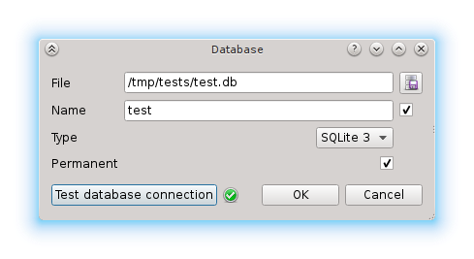You can press "Test connection" to make sure that your database file can be created in specified localisation (in regards of directory permissions, free space, etc). If everything is okay, than you will see green icon next to it:

If there was any problem, the red icon will appear.

You can now press "Ok" to create the database. You will see it in the databases list on the left:

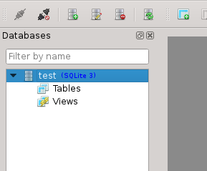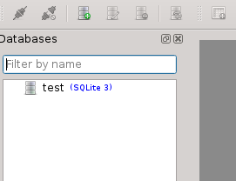

Double-click to open it:

**Permanent vs transient database**

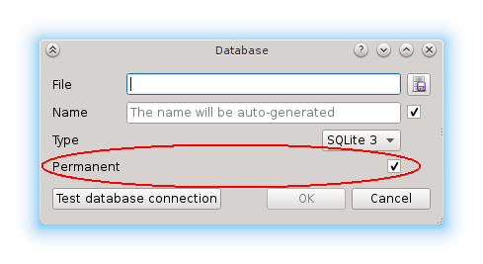You may have noticed the "Permanent" check in the database dialog:

When this option is checked, then the database is added permanently to SQLiteStudio. This means that when you close SQLiteStudio and start it again, the database will remain on the list.

If this option is not checked, then the databases will disappear from the list after SQLiteStudio was restarted.

Now SQLite Studio has many capabilities for working with tables and databases with SQLite. For our purposes we're going to be using the SQL editor. Select the SQL editor or use the Alt + E key to open it by pressing on that icon there that looks like a piece of paper with a pencil.

 In SQLite Studio, go to Tools, Open configuration dialog. And under Look & Feel here, and in Fonts, you can adjust the font size or color, but I recommend to not change if it is not necessary.

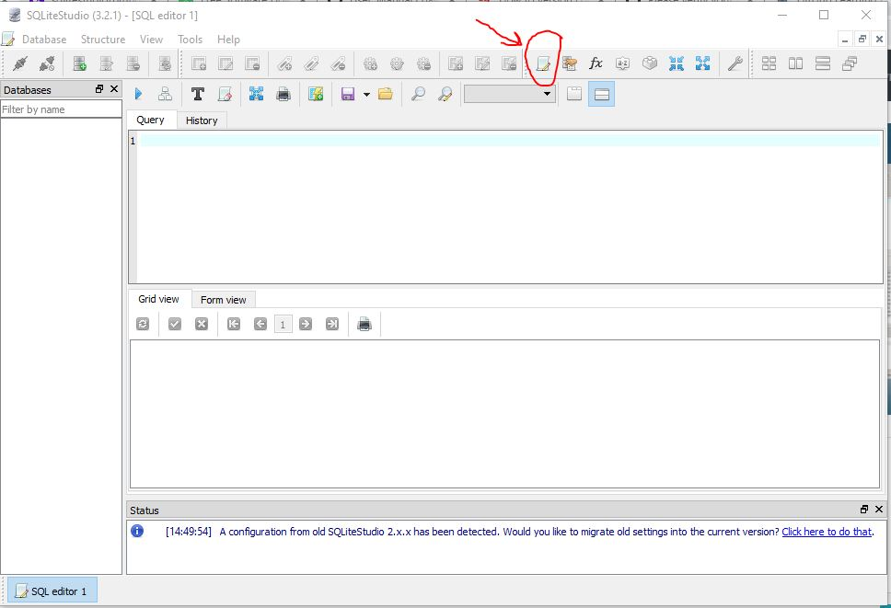

And this will allow us to type SQL directly into the management system here and execute that SQL in the database system.